**Advantages of cloud computing**

1. 24/7 availability & accessibility:

* It is available & accessible from anywhere & at any time we only need to have device and internet connectivity to access the azure resources/ services.

1. Scalability:

* the face of transformation is very simple and ease in cloud computing (ex: resizing of resources/ workloads/services/ etc) and that can be done by just a click of mouse.

1. Security:

* It is using a very high security algorithm and hash functions to protect our data & resources.

1. Enhanced collaboration:

* Just in one platform(portal.azure.com) you are going to get all the resources / services that you need for your project and application requirement.

1. Cost effective:

🡪 It is very much cheap an economical as compared to private cloud or an old legacy system.

1. Reliable:

* Cloud services are consistently good in quality with equal performance even if we perform multiple enhancement on them.

**Cloud Computing Resources/ Services**

Azure cloud computing is offering 200+ resources/ services.

**What are Azure resources/ services?**

* Anything that we are creating/deploying as a part of our application need is called as resource or service. Example: Virtual machines, databases, Storage accounts, Virtual machines, container instances, load balancers, app services etc.
* All these resources/ services are the ingredients for the application development and deployment.

Now, these resources and services are divided in different service models:

1. ***IaaS 🡪 Infrastructure as a Service***

***🡪*** *ex. VM, SA, Vnet, AAD etc****.***

1. ***PaaS 🡪 Platform as a Service***

*🡪Ex. SQL DB, Cosmo DB, etc.*

1. ***SaaS 🡪 Software as a Service***

*🡪Ex: Skype, Gmail, FB, WhatsApp etc*

When we are developing, building or creating our applications we always take a combination of IaaS and PaaS. No software/application can be built only with IaaS or PaaS. We always take a combination of both to build successful application.

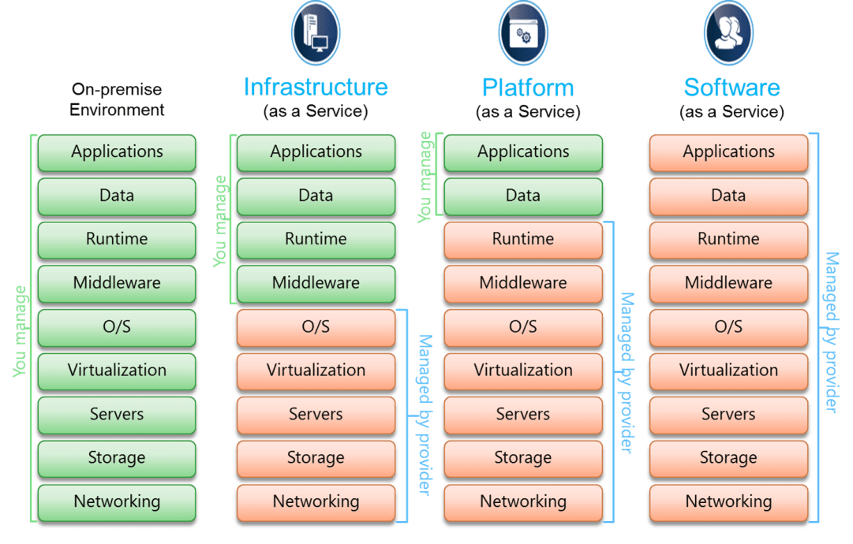

For details, please refer blog:

https://hashnode.com/preview/66da239bc0f53bee1f300b17